General paper
SENIOR FIVE TERM 3
TOPIC 2/2: Data collection and analysis
Competence: The learners supports evidence based decision making through collecting, analyzing, interpreting and communicating using a range of media to solve societal problem. Data collection methods
In research, data collection methods are the techniques used to gather information for analysis. They can be broadly divided into primary (directly collected by the researcher) and secondary (collected by others but used for your study). Here’s a clear breakdown:
Types of Data Collection Methods

1. Observation
- Watching and recording behaviors, events, or conditions in natural or controlled settings.
- Example: Observing classroom interactions to study teaching methods. • Best for: Behavioral studies, anthropology, and social sciences.

2. Interviews
- Direct questioning of individuals (structured, semi-structured, or unstructured).
- Example: Asking community members about their experiences with healthcare. • Best for: In-depth qualitative insights.

3. Questionnaires/Surveys
- Written or digital forms with structured questions.
- Example: Online survey about consumer preferences.
- Best for: Collecting large amounts of quantitative data quickly.

4. Focus Groups
- Group discussions guided by a facilitator to explore opinions and attitudes.
- Example: Discussing youth perceptions of social media.
- Best for: Exploring collective views and generating ideas.

5. Experiments
- Controlled studies where variables are manipulated to observe effects.
- Example: Testing the impact of a new teaching method on student performance.
- Best for: Scientific and psychological research.

6. Document/Content Analysis
- Reviewing existing records, reports, books, or media.
- Example: Analyzing government policy documents on human rights. • Best for: Historical, legal, or media studies.
7. Case Studies • Detailed examination of a single subject, group, or event. • Example: Studying one village’s response to climate change.
• Best for: Deep, contextual understanding.

8. Secondary Data
- Using data already collected by others (e.g., census, databases, published research).
- Example: Using World Bank statistics for economic analysis. • Best for: Large-scale, comparative studies.
Why Different Methods Matter
- Observation & interviews → rich qualitative insights.
- Surveys & experiments → reliable quantitative data.
- Document analysis & secondary data → cost-effective and broad coverage. • Focus groups & case studies → nuanced understanding of specific contexts.
In short: Researchers often combine several methods (called triangulation) to strengthen validity and reliability of findings.

Data presentation styles

Common Data Presentation Styles
Style | Description | Best Use Case
Tabular | Data arranged in rows and columns | Precise numerical comparisons, structured datasets
Textual | Data explained in words or paragraphs | Summaries, qualitative insights, reports
Pie Chart | Circular chart showing proportions | Showing percentages or parts of a whole
Bar Chart | Rectangular bars comparing categories | Comparing discrete groups or categories
Histogram | Bars showing frequency distribution | Statistical data, frequency analysis
Line Graph | Points connected by lines | Trends over time, continuous data
Pictogram | Icons or images representing data | Simplified visuals for general audiences
Radar Chart | Web-like chart with multiple axes | Comparing multiple variables at once
Heat Map | Color-coded grid showing intensity | Geographic data, performance metrics
Scatter  Plot | Dots showing relationship between variables | Correlation, regression analysis

Why Presentation Style Matters
- Clarity: The right style makes complex data easy to understand.
- Audience engagement: Visuals like charts and maps capture attention better than raw numbers.
- Decision-making: Clear presentation helps stakeholders interpret insights quickly.
- Accuracy: Some styles (like tables) preserve detail, while others (like pie charts) simplify for overview.

Risks & Challenges
- Misleading visuals: Poorly scaled charts can distort meaning.
- Overcomplication: Too many styles at once confuse the audience.
- Audience mismatch: Technical graphs may overwhelm non-specialists.

Data collection and presentation (for your practice)
Data refers to the set of values or observations collected to analyzed and interpreted in order to make decisions. It can be numbers, prices, temperature, measurements, or observations— basically anything that helps us to understand a situation or solve a problem.
Information is set of data that has been organized into useful and intelligible form that form a basis for decision making.

Data analysis
Data analysis is the process of examining, organizing, and interpreting data to uncover useful insights, answer questions, and support decision-making.

Steps in data analysis
- Define the Objective o What question are you trying to answer?
o Example: “Why did sales drop last month?”
- Collect the Data o Gather info from surveys, databases, sensors, or websites. For example, recording the heights of students in your class, recording temperature of the class at noon for one month, marks score by learners in a mathematic test, etc.
- Clean the Data o Fix errors, remove duplicates, and fill in missing values.
- Explore the Data o Use charts, graphs, and statistics to spot patterns or outliers.
- Analyze the Data o Apply methods like regression, clustering, or hypothesis testing.
- Interpret Results o What do the patterns mean? What decisions can be made?
- Communicate Findings o Create dashboards, reports, or presentations to share insights. Types of Data Analysis
Type | Purpose | Example
Descriptive | Summarize past data | Average monthly sales
Diagnostic | Explain why something happened | Why sales dropped in June
Predictive | Forecast future outcomes | Expected sales next quarter
Prescriptive | Recommend actions | Best time to launch a new product

Presentation of data
Data can be presented in five ways namely
- Pictogram
- Pie charts
- Tables
- Bar charts/Histograms
- Line graphs

Pictograms/Pictographs
Pictograms /pictographs are visual tools used to represent data using pictures or symbols. They’re especially helpful for making information easy to understand at a glance—perfect for younger learners or quick summaries!

What Is a Pictogram?
- A chart or graph that uses images to show quantities.
- Each image represents a specific number of items.
- Often includes a key to explain what each symbol stands for.

Imagine a survey of favorite fruits among students:
Fruit | Number of Students | Pictogram ( = 5 students)
Apples | 15 | 
Bananas | 10 | 
Oranges | 5 | 
Here, each icon represents 5 students. So 3 = 3 x 5 =15 students.

How to Create a Pictogram
- Collect your data (e.g., number of books read).
- Choose a symbol that matches your topic.
- Decide the value of each symbol (e.g., 1 icon = 10 units).
- Draw the chart with categories and symbols.
- Include a key to explain the symbol’s value.

Advantages of pictographs
- Easy to read and interpret
- Visually engaging
- Great for comparing categories quickly
Example 1
A car company sales several types of vehicles; the pictogram below represents the number of each type of vehicles found on display on a certain day.
Vehicle type | icon
Toyota | 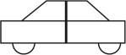
Isuzu | 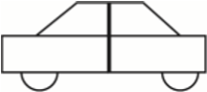  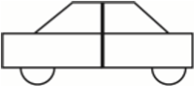  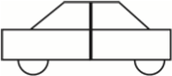
TaTa | 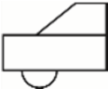
Daihatsu | 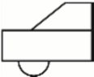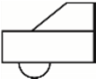
Key
represents 10 vehicle
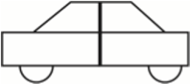
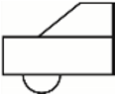
represents 5 vehicle
- How may Toyotas were on display on that day
10 x 4 = 40
- Which vehicle was least displayed on that day
Daihatsu
- How many vehicles were displayed altogether
10 4 + 3 + 2½ + 1½ ) = 11 x 10 = 110vehicle

Trial 1
- The pictogram below show the number of trees cut from the forest on each day of the week for one week.
Days of the week | Number of trees cut
Monday | 
Tuesday
Wednesday | 
Thursday
Friday | 
Key:
represents 2000 trees


represents 1000 trees
Calculate
  - Number of trees cut on each day (b) Total number of trees cut in five days.
- The table below show number of oranges in boxes A, B, C and D
Boxes | A | B | C | D
Number of oranges per box | 45 | 40 | 35 | 25
Use an appropriate icon to draw a pictogram for the data above.
- The pictogram below represents number of oranges served to each class at lunch on Monday.
Class | Number of students | Number of oranges served
S1 | 41 | 
S2 | 57 | 
S3 | 35 | 
S4 | 30 | 
Key
 = 5 oranges
  - In which class were oranges in excess of the number of students?
  - In which class were oranges fewer than the number of students?
  - Find the total number of oranges served to the school

Tables
Tables are structured formats used to organize and present data clearly and efficiently. They help summarize large amounts of information so that patterns, comparisons, and insights can be easily spotted.

Tables are made of:
- A grid of rows and columns that displays data values.
- Each row typically represents a category or observation.
- Each column shows a variable or characteristic.
- Often includes titles, headings, units, and sometimes a source.

Trial 2
The table below shows number of students in The Science foundation College
Class | S1 | S2 | S3 | S4 | S5 | S6
Boys | 23 | 35 | 60 | 53 | 70 | 42
Girls |  | 43 |  |  | 45 | 47
Total | 60 |  | 90 | 92
- Fill the blank spaces in the table
- Which class has the highest number of students
- Which class has the least number of students
- What is the total number of students in the school

Pie charts
Pie charts are circular graphs used to show how a whole is divided into parts. Each slice of the pie represents a category, and the size of the slice shows how much of the total it makes up.

How to Create a Pie Chart
1. Collect your data Example: Number of student in school
Class | S1 | S2 | S3 | S4
Number of students | 64 | 48 | 32 | 16

2. Convert numbers to angles
Total number of students = 64 + 48 + 32 + 16 = 160
Angle size covered by S1: 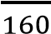× 360 = 144°
Angle size covered by S2: × 360 = 108°
Angle size covered by S3: 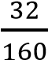 × 360 = 72°
Angle size covered by S4: 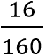 × 360 = 36°
3. Draw the circle and measure angles Use a protractor to draw each slice from the center.
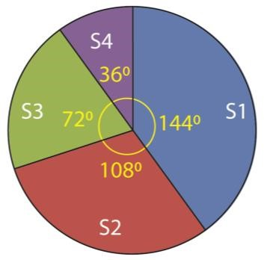

Why Use Pie Charts?
Benefit | Description
Easy to understand | Great for showing proportions at a glance
Visually appealing | Makes data more engaging and memorable
Ideal for comparisons | Quickly compare parts of a whole

When Not to Use Pie Charts
• If you have too many categories (more than 5–6)

• If the differences between values are small
• If you need to show trends over time (use line or bar charts instead)

Trial 3
- Draw a pie chart to represent David’s monthly expenditure in the table below
Food | 450,000
Electricity | 200,000
Phone call | 100,000
Clothing | 250,000
- The table below shows how Dr. Bbosa Science uses his land
Land use | Coffee | Cotton | Maize | Grazing
Land size (ha) | 4.5 | 3 | 2.5 | 2
Draw a pie chart to represent the information above
- Moses earns sh. 1,200,000 and spends it as shown on the pie chart.
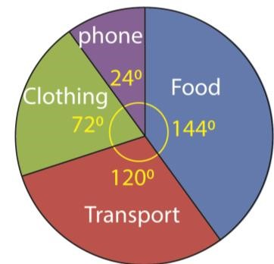
Find how much is spent on each item.
- Yoweri spent his monthly salary as shown in the pie chart below
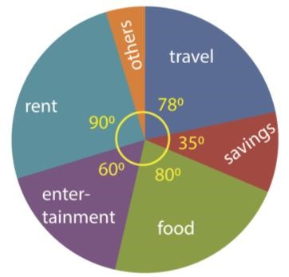
If his monthly salary is sh. 2,000,000/= find how much he spends on each item.
- The pie chart below represent the subjects taught by 45 science teachers
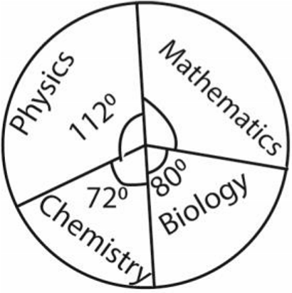
Determine the number of teachers who teach mathematics [12]
- The pie chart below shows the fruits popularly solid in a daily supermarket in Kampala
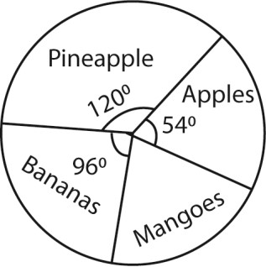
If 420 apples were sold on a given day, determine
  - The total number of fruits that were sold that day [2800]
  - How many mangoes were sold that day. [700]

Bar charts
Bar charts are one of the most popular and easy-to-read ways to display data visually. They use rectangular bars to represent values, making it simple to compare categories side by side.
Bars can be vertical or horizontal. The length or height of each bar represents the value of the data.
Uses Bar Charts
- Comparing quantities across categories
- Showing survey results
- Visualizing frequency distributions
- Tracking changes over time (if categories are time-based)
Example 2
- The bar graph below shows heights in cm of 7 boys from Kelima secondary School. Use it to answer the questions that follow;
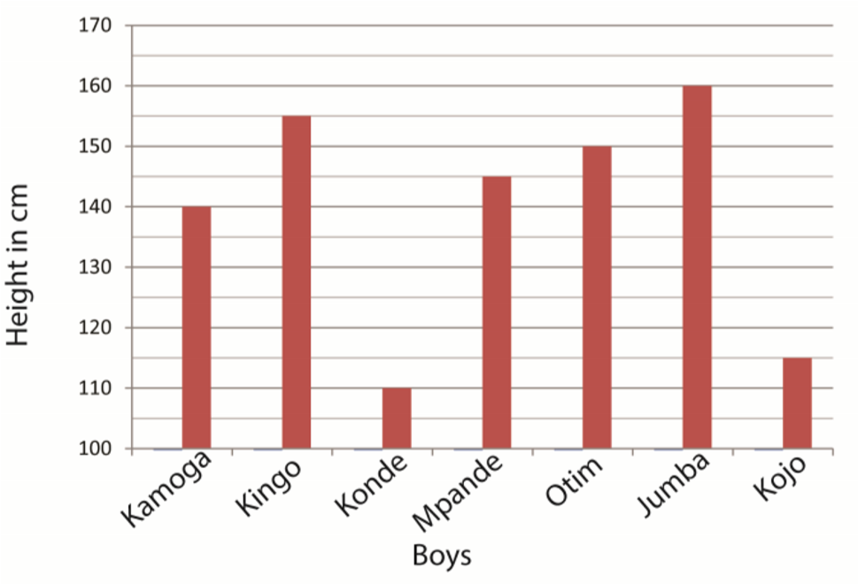
  - Complete the table below
Kamoga | Kingo | Konde | Mpambe | Otim | Jumba | Kojo
145cm | 155cm | 110cm | 145cm | 150cm | 160cm | 115cm
  - What is the height of the shortest boy?
The height of the shortest boy = 110cm
  - What does one square on the vertical axis represent? :
1square vertical axis = 5cm
  - What is the average height of the boys
Average height of the boys = 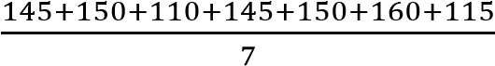=125cm
- The graph below shows the number of student present in a class of 40 pupils in a certain week. Study it and answer the questions that follows
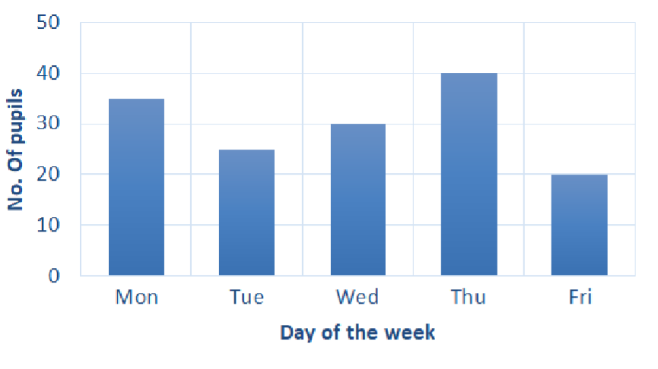
Find the average number of student who were absent in the week.

Days | Number of students present out of 40 | Number of students absent
Mon | 35 | 40-35=5
Tue | 25 | 40-25=15
Wed | 30 | 40-30=10
Thur | 40 | 40-40=0
Fri | 20 | 40-20=20
Average number of pupils absent in the five days = 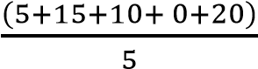
= 10 students/day

Trial 4
- The data below shows the number of students that attended school on the different days of the week.
Monday | 300
Tuesday | 250
Wednesday | 350
Thursday | 400
Friday | 200
Draw a bar chart to represent the above data.
- The table below shows number of oranges, lemons, tomatoes, tomatoes sold on a market day by a trader.

Name of the  fruit | Oranges | Lemon | Tomatoes
Number sold | 5 | 12 | 8 | 4
Represent the data on
  - Vertical bar chart
  - horizontal bar chart
- The table below contains number of candidates that sat final examination five school A, B, C, D and E.
Schools | Number of candidates
A | 40
B | 56
C | 80
D | 32
E | 60
Represent the information on a bar chart.
- The number of visitors accommodated per night by a certain hotel was recorded over a period of a month.
No. of visitors | 0<10 | 10<20 | 20<30 | 30<40 | 40<50
No. of nights | 2 | 8 | 12 | 5 | 3
Using a scale of 1cm to represent 2 nights and 1cm to represent 10 visitors, display the given data on a bar-graph. Use your bar-graph to estimate the modal number of visitors accommodated by the hotel [24]

Histogram
Histogram resembles a bar graph or bar chart with the bars touching one another for continuous data.
A frequency polygon is the line graph that joins the midpoints of the bars of a histogram.
Example 3
The table below shows number of oranges sold at a grocery in one week
Day of  the week | Mon | Tue | Wed | Thu | Fri | Sat | Sun
Number of orange sold | 200 | 230 | 180 | 210 | 300 | 280 | 320
- Draw a histogram to represent the data.
- Use the histogram to construct a frequency polygon
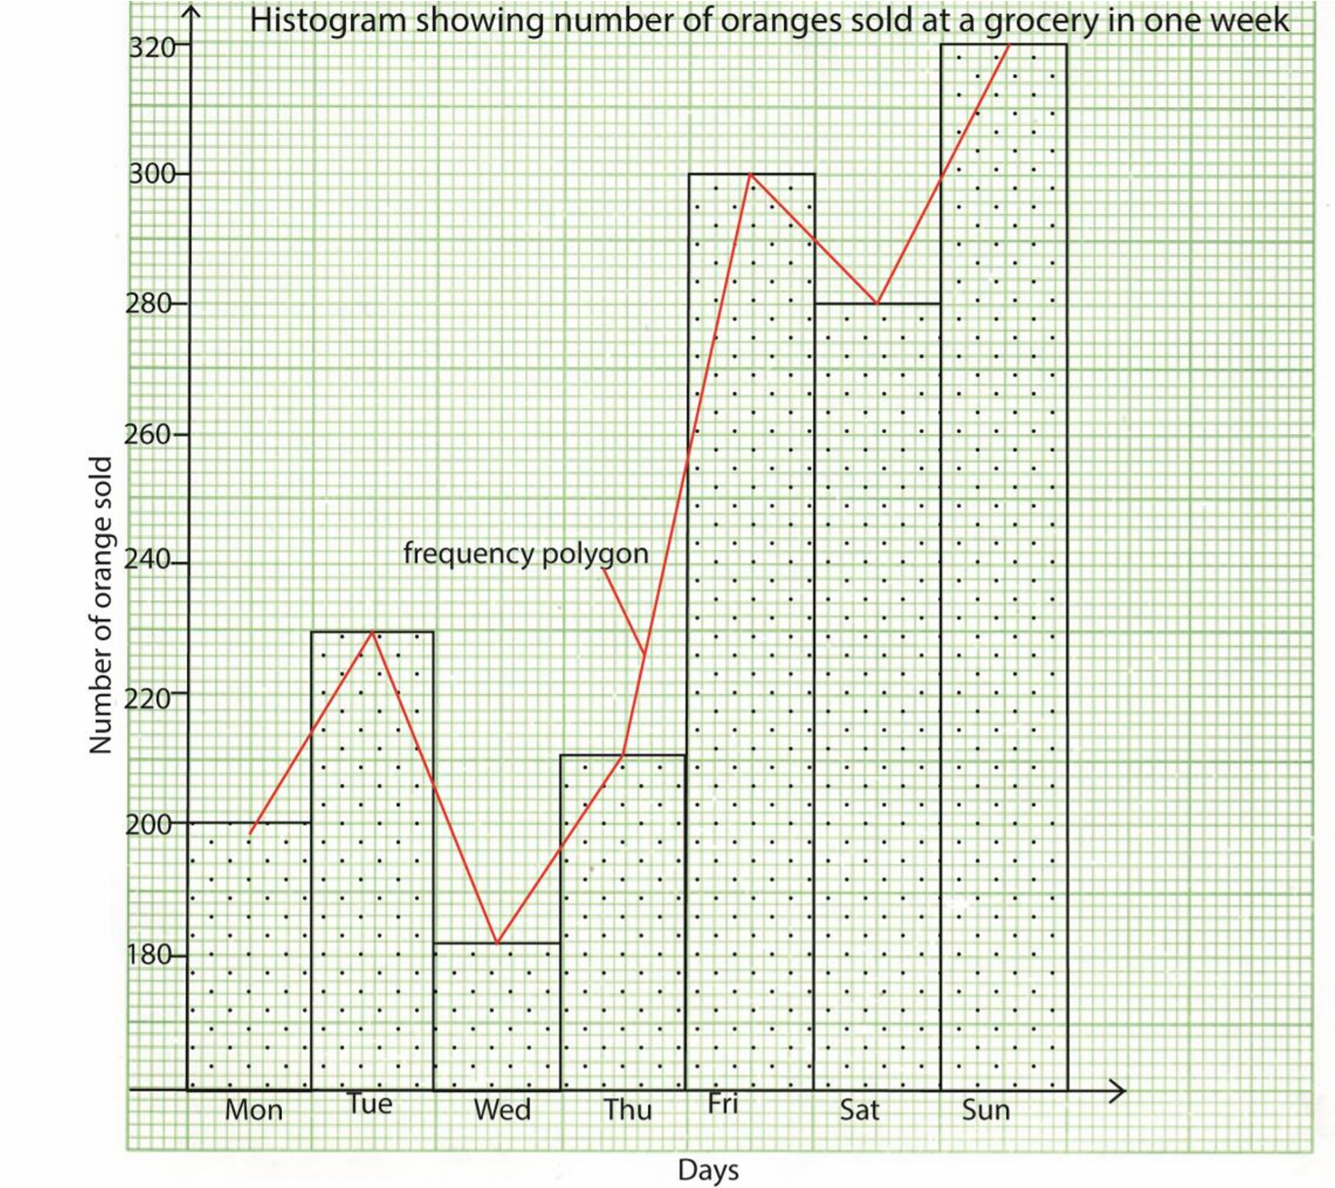

Trial 5
1. The table below shows age of120 students entering senior one.
Age (years) | 12.5 – 12.9 | 13.0 – 13.4 | 13.5 – 18.9 | 14.0 - 14.4 | 14.5-14.9
No. of students | 8 | 35 | 52 | 17 | 8
- State the
  - class width [0.4]
  - modal class [13.5-13.9]
- Determine the mean and median age of the students [13.625, 13.61]

